**DEPARTMENT OF LINGUISTICS** 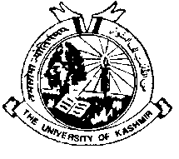

**University of Kashmir, Srinagar**

**Hazratbal Srinagar 190006(J&K)**

**Prof Aejaz Mohammed Sheikh**

**(Prof.& Head)**

**NOTICE**

All the students of M.A. 3rd Semester are hereby informed that the examination of the Postponed paper ***English communicative Skills (LN17008DCE)*** shall nowbe held on 20-03-2019 (Wednesday).

Sd/=

**Head of the Department**